FREE INTERDISCIPLINARY WEBINAR
Distinguishing Cognitive Problems from Depression in Older Adults
CERTIFICATES OF ATTENDANCE PROVIDED!

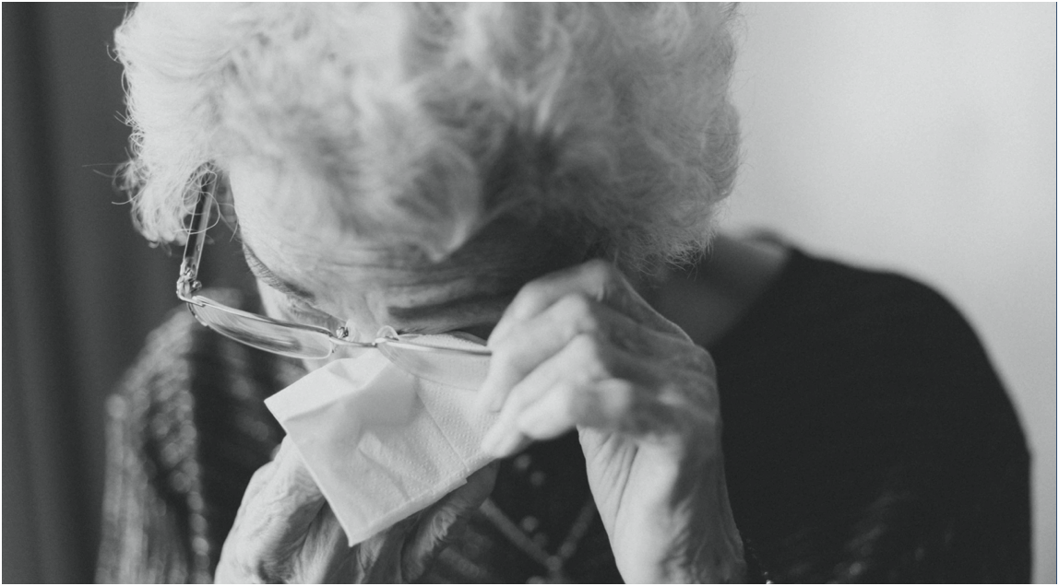
Monday September 28, 2020
11:00 am – 12:00 pm
REGISTER HERE!*
Please join us for a free AgingME GWEP Interdisciplinary Seminar Hosted by the University of Maine’s Clinical Psychology Program led by Angelica Boeve, M.A. This seminar will discuss depression and important issues in working with older adults, such as distinguishing depressive symptoms from cognitive problems in older adults.
As a result of attending this seminar, participants will be able to:
- Describe the typical presentation of depressive symptoms in older adults.
- Explain similarities and differences between depression and cognitive problems in older adults.
- Identify steps for referral, assessment, & treatment of depression in older adults.
*Registration required. Once your registration has been confirmed, an invitation will be sent to you via email. If you are unable to attend the event live, and wish to view the recorded webinar, please register and make a note in the questions/comments box that you would like access to the recording.

